<http://www.igiit.net/admin/Admin_UploadDocs.aspx>

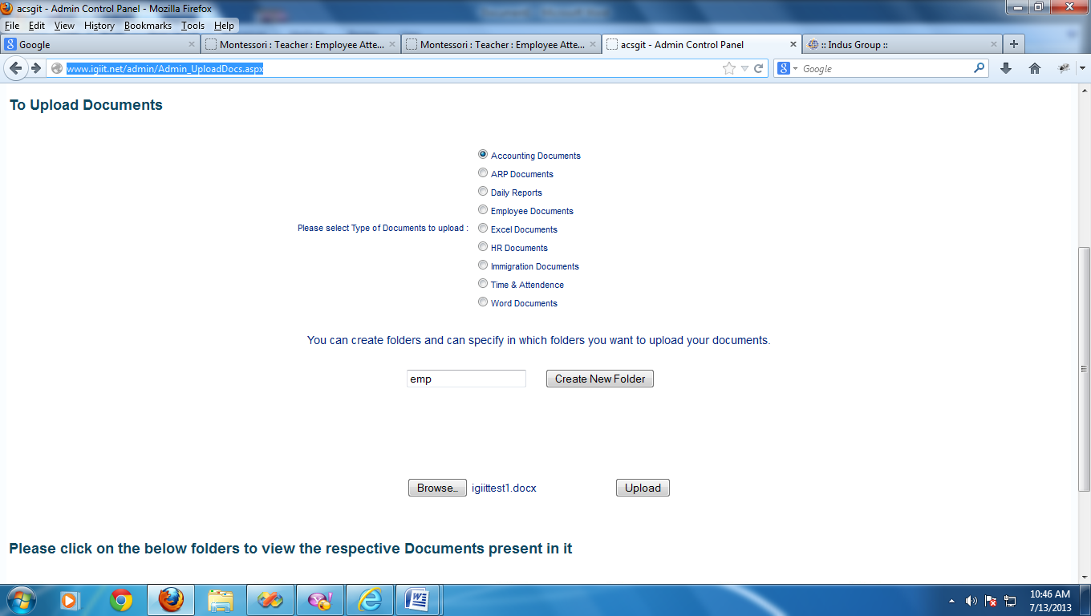

Below Error will come when we click on this button

This button is not working properly

<http://www.igiit.net/admin/Admin_UploadDocs.aspx>

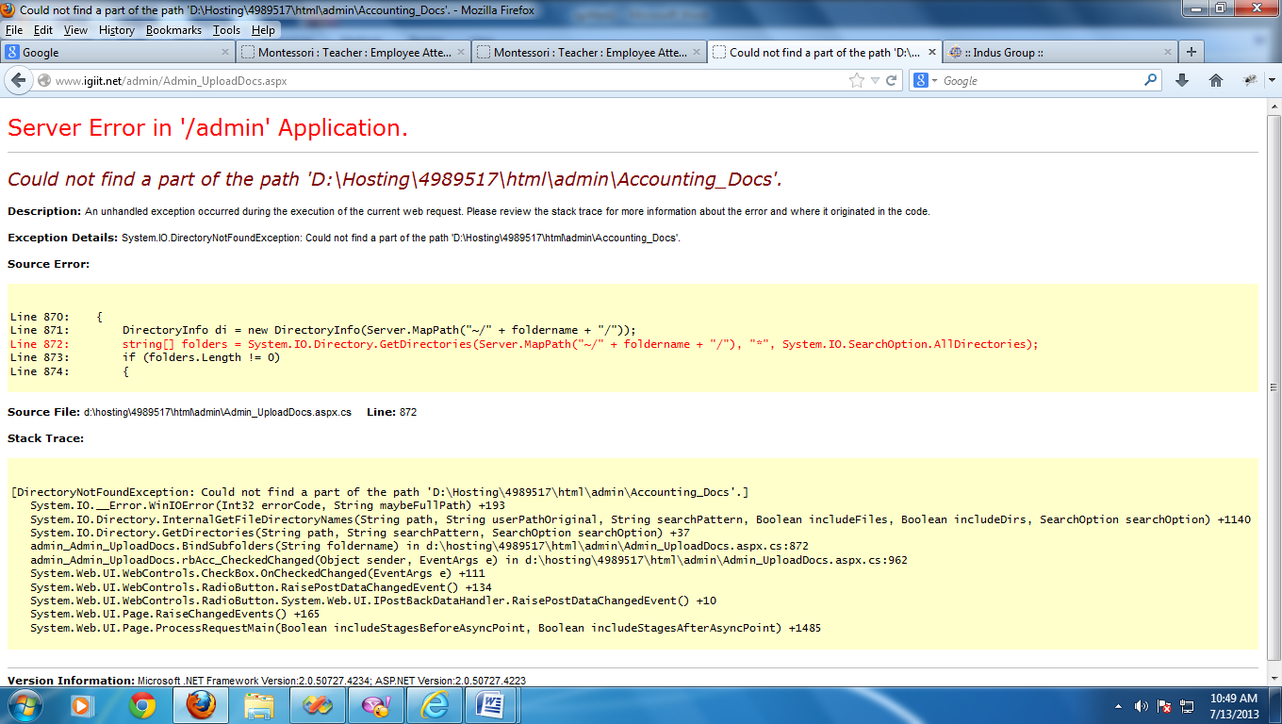

<http://www.igiit.net/admin/Admin_TimeSheet_Create.aspx?cid=117>

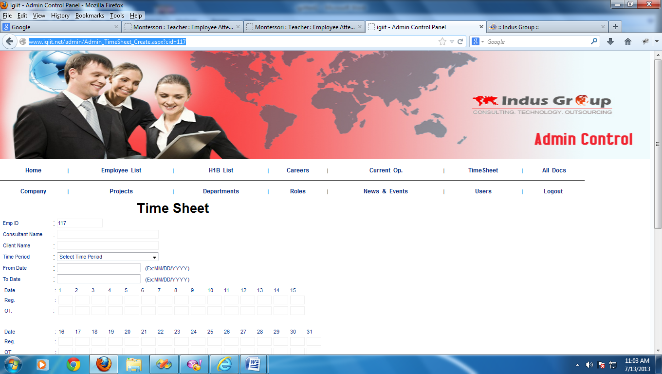

No validations for these two fields

<http://www.igiit.net/admin/Admin_EmpNewFrmCreate2.aspx>

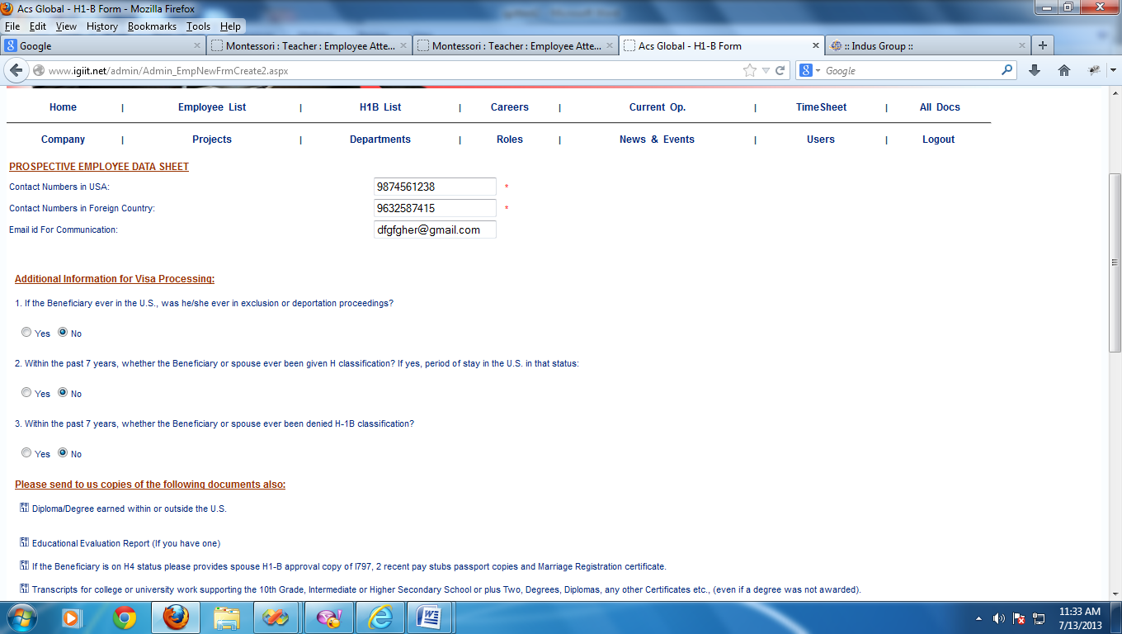

Check these validations. it’s not working properly

<http://www.igiit.net/admin/Admin_EmpID.aspx?cid=77>

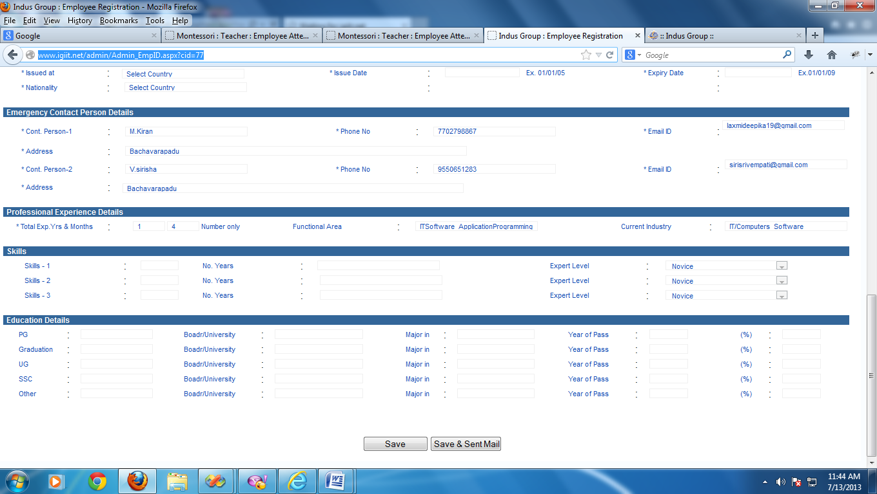

Save button does not working

<http://www.igiit.net/admin/Company_Create.aspx>

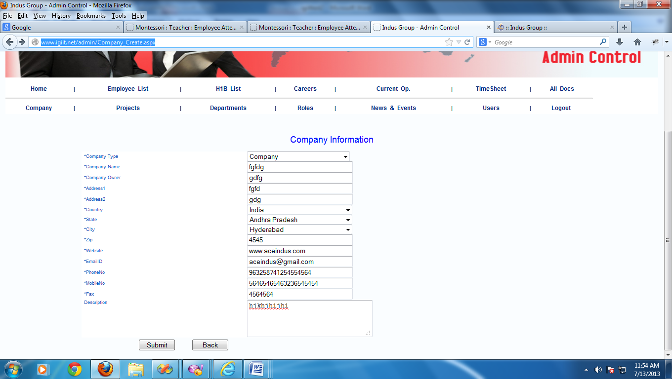

These two text boxes allows more than 10 numbers

<http://www.igiit.net/admin/Admin_EmpEdit.aspx?cid=87>

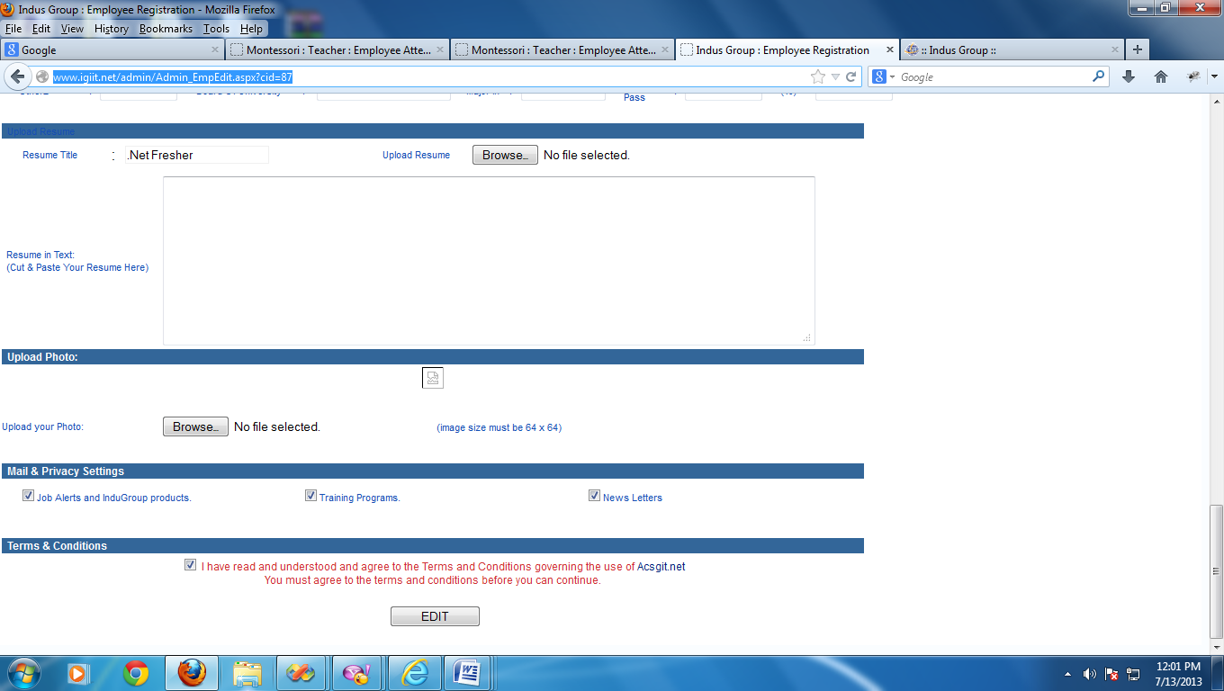

Image not displayed

<http://www.igiit.net/admin/Projects.aspx>



By default this message is dispalying